**Machine Learning Project on E-commerce**

**Introduction**

E-commerce, or electronic commerce, refers to the buying and selling of goods and services over the internet. In today’s era, e-commerce has become an increasingly popular way for people to shop and do business. Some of the reasons for the bloom of e-commerce in present times are convenience, easy accessibility, a wide variety of products, and global reach. The COVID-19 pandemic has drastically changed the way people live, work, and shop, and this has had a significant impact on the e-commerce industry. Every day, more and more companies are going online, and they all want to increase their revenue. The revenue of ecommerce refers to the total amount of money earned by an ecommerce business through the sale of goods or services over a specific period of time. The revenue of an e-commerce business can be influenced by various factors, including the volume of sales, pricing strategy, time spent on a website etc. E-commerce has revolutionized the way we conduct business and it is expected to continue to grow and evolve in the future.

**Business Problem Statement**

Due to the recent boom in e-commerce, there is fierce competition among shopping websites to boost their earnings. In this study we predict whether customer will buy product (spend money) on a shopping website or not.

**Data Characteristics**

Data from UCI Machine Learning Repository is used for analysis. There are 12330 rows and 18 variables in the dataset. Revenue is the dependent variable and the rest other variables are independent variables.

Administrative, Informational and Product Related represent the number of different types of pages visited by the visitor in that session while Administrative Duration, Product Related Duration and Informational Duration represent the time spent by user in each of these page categories. Bounce Rate represents the percentage of visitors who arrive on a website and leave before going to second page while Exit Rate is the percentage of visitors who leave website after a particular page. The Page Value represents the average value for a page that a user has visited before landing on goal page or completing an e-commerce transaction or both. The Bounce Rate, Exit Rate and Page Value represent the metrics measured by Google Analytics for each page in e-commerce website.

The special day represents a few days before and after any special day like Mother’s Day, Valentine’s Day etc. as usually sales go up during these special days. The visitor type variable tells us whether the customer is a returning customer or a new customer. The Traffic Type variable means how did the user land on a particular website. There are various traffic types like direct, Organic, Referral, Social, Email, Paid etc. Other variables include the month, region type, browser, weekend and revenue. Revenue and weekend are binary variables.

Link of Dataset: [https://archive.ics.uci.edu/ml/datasets/Online+Shoppers+Purchasing+Intention+Dataset#](https://archive.ics.uci.edu/ml/datasets/Online+Shoppers+Purchasing+Intention+Dataset)

Glimpse of Dataset

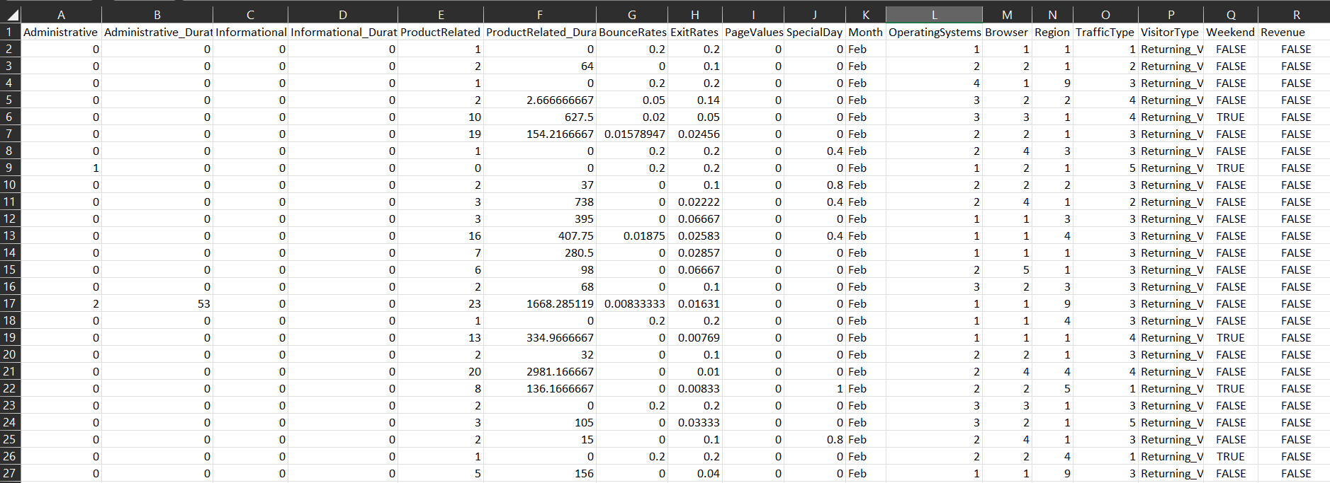

Figure 2.1: Glimpse of Dataset

**Exploratory Data Analysis:**

The first step is loading the dataset after importing the necessary libraries. The *data.head()* command is used to view the first five rows of dataset.

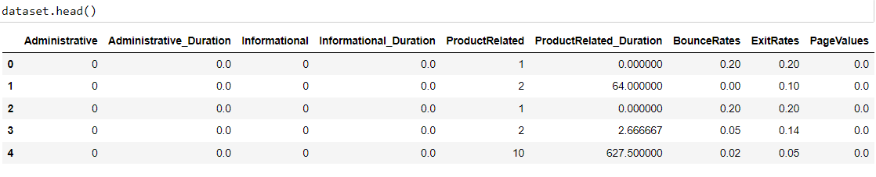

Figure 2.2: Viewing the first 5 observations of Dataset

Then the dimensions of data are found out using the *dataset.shape* command. The dimensions of dataset are 12330 X 18. The next step involves finding missing values. There are no missing values in our data. The datatypes of variables are found out. Integer, Float, Boolean as well as Object datatypes are present.

Descriptive analysis is found out using the *dataset.describe()* command. It gives the values of mean, minimum, all 3 quartiles, standard deviation and maximum.

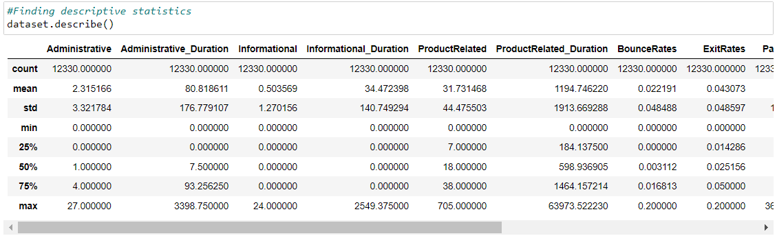

Figure 2.3: Descriptive Statistics

Next histogram is plotted. From histogram we can observe that all variables are positively skewed.

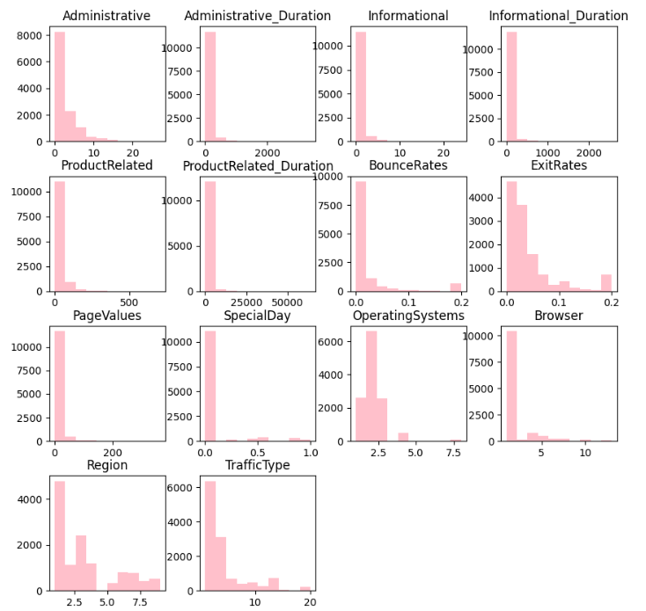

Figure 2.4: Histogram

Boxplot is plotted to detect the presence of outliers. Outliers are present in Administrative Duration, Product Related Duration and Informational Duration

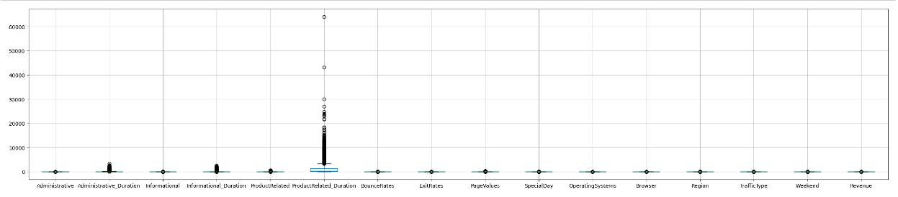

Figure 2.5: Boxplot

The counter function from collections library is used to count the number of specific types of values in Visitor Type, Revenue, Weekend and Region. Using it we find out that:

* There are 10551 Returning Visitors, 1694 New Visitors and 85 Other Visitors
* Out of 12330 people visiting the website 10422 people do not buy anything (spend money) while only 1908 spend money
* 9462 people visit the website on weekends while 2868 people visit during weekdays.
* 4780 people are from region 1, 1136 people are from region 2, 2403 people are from region 3, 1182 people are from region4, 318 people are from region 5, 805 people are from region 6, 761 people are from region 7 while 434 people are from region 8 and 511 people are from region 9.

Bar plot and line graph are plotted to see the distribution of revenue over Visitor Type, Month, Region, and Traffic Type

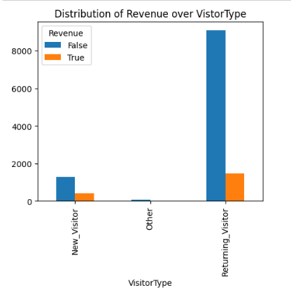

Figure 2.6: Distribution of Revenue over Visitor Type

The proportion of new customers visiting the website and buying products is higher than the proportion of returning customers visiting the website and purchasing products (spending money). Other types of visitors hardly visit the website or make any purchase.

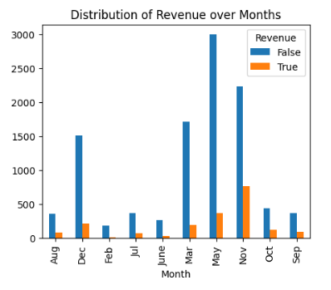

Figure 2.7: Distribution of Revenue over Months

Most people visited the website in the month of May, November and December, whereas the most purchases that occurred happened in November.

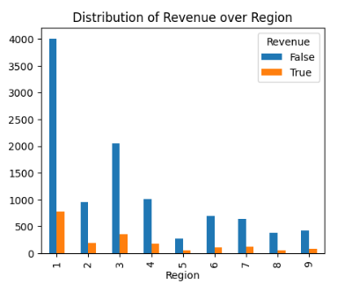

Figure 2.8: Distribution of Revenue over Region

The website is most visited by people from region 1. Most of the customers are from region 1 to region 5. They are more prone to making purchases.

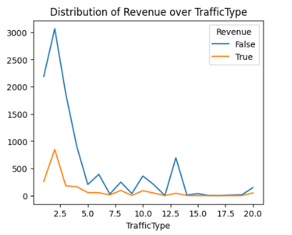

Figure 2.9: Distribution of Revenue over Traffic Type

We can see that different Traffic Type browsed the web page and out of which few of them made the purchase from the website.

The next step is to assign independent variable X and dependent variable Y their respective values. Revenue is the dependent variable and all other variables are independent variables. There are categorical variables in our dataset. We use dummy variables for transforming Month and Visitor Type. Label encoding is used on dependent variable Y and it is fitted.

A heatmap is plotted in order to understand the correlation between all variables. The lighter shades of heatmap indicate positive correlation while the darker shades indicate negative correlation. There is a moderate negative correlation between Page Value and Bounce Rate.

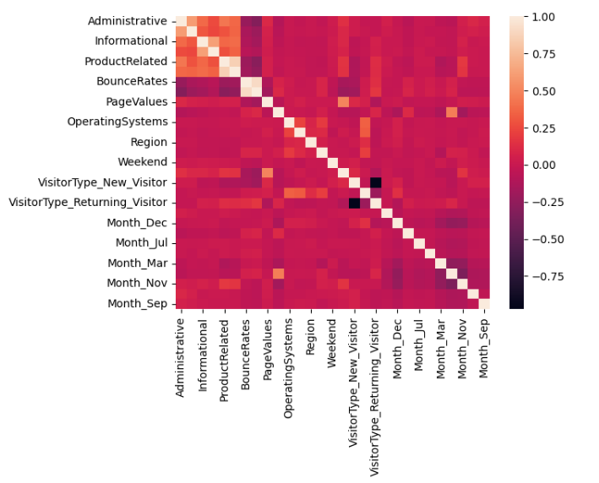

Figure 2.10: Heatmap

**Analysis**

The dataset is split into train and test set in the ratio of 80:20. This means that 20% of our data points will be in test set and 80% of them will be in the train set. Random state is taken to be 0 indicating that we will get the same train and test sets across different executions.

Then the values of X_train, X_test, Y_train and Y_test are printed. Feature scaling is applied in order to reduce the dominance of some features. Since our data is not normal, standardisation is used. The goal of standardization is to have all values in the same range. Firstly, **Logistic Regression** is used in order to train the model on the Training set. This is done by calling the Logistic Regression class from the linear model module of scikit learn library. Thus, a logistic regression model is fitted. The next step is to predict the results of the test set.

In order to check the accuracy of the model, a confusion matrix is created. It is a simple 2D matrix which shows the number of correct predictions and the number of incorrect predictions made in the test set. The accuracy score function is used to find the accuracy of the test set. It is used to determine the performance of the test set.

In a similar manner, **K Nearest Neighbour (KNN)**, **Support Vector Machine (SVM)**, **Decision Tree** and **Random Forest** Models are also fitted. The confusion matrix of all models is created. The model whose confusion matrix gives the most accuracy is best model for our dataset.

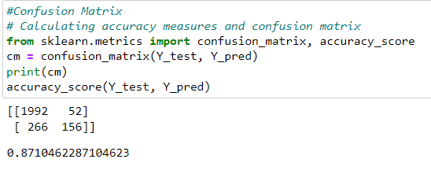

Figure 2.11: Confusion Matrix of Logistic Regression

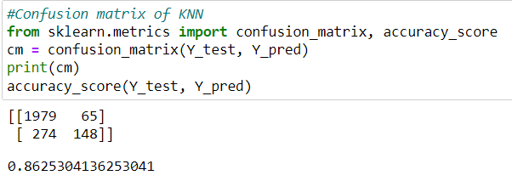

Figure 2.12: Confusion Matrix of KNN

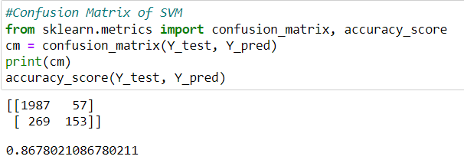

Figure 2.13: Confusion Matrix of SVM

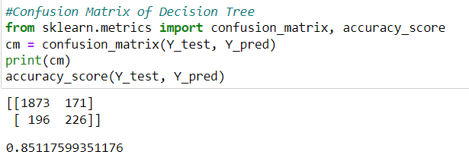

Figure 2.14: Confusion Matrix of Decision Tree

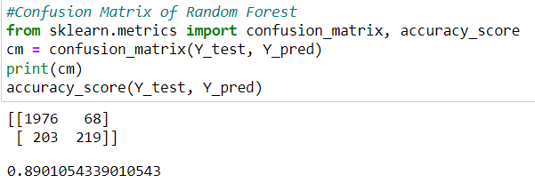

Figure 2.15: Confusion Matrix of Random Forest

**Conclusion**

The accuracy score of our logistic regression model is 87.10% indicating that the model makes correct predictions 87% of the times. The accuracy score of KNN is 86.25%, while the accuracy score of SVM is 86.78%. The accuracy of SVM is just slightly more than the accuracy of KNN. The accuracy score of Decision Trees is 85.11%, while the accuracy score of Random Forest Model is 89.01%. Since the accuracy scores of all models are well above 85% percent, all the models are a good fit for our data, but the best model is that of Random Forest as it gives an accuracy of 89%. From the confusion matrix we can observe that there are 1976 True Positives (TP), 68 False Positives (FP), 203 False Negatives (FN) and 219 True Negatives (TN) values. This means 1976 times we predict that user spend money on our website and 1976 times they actually spent money on the website. 68 times we predicted that the user would not spend money but they did spend money. 203 times we predicted that the user will spend money but they did not spend any money on the website and 219 times we predicted that the user will not spend money on the website and in fact they did not spend any money.